# CS 255 System Design Document Template

**Module 7**

**Marissa Lanza**

**June 21, 2024**

This template lays out all the different sections that you need to complete for Project Two. Each section has guidance to prompt your thinking. You will need to continually reference the interview transcript as you work to make sure that you are addressing your client’s needs. There is no required length for the final document. Instead the goal is to complete each section based on what your client’s needs are. Remove this note when you are finished, and replace all bracketed text with the relevant information.

## UML Diagrams

### UML Use Case Diagram

### UML Activity Diagrams

### UML Sequence Diagram

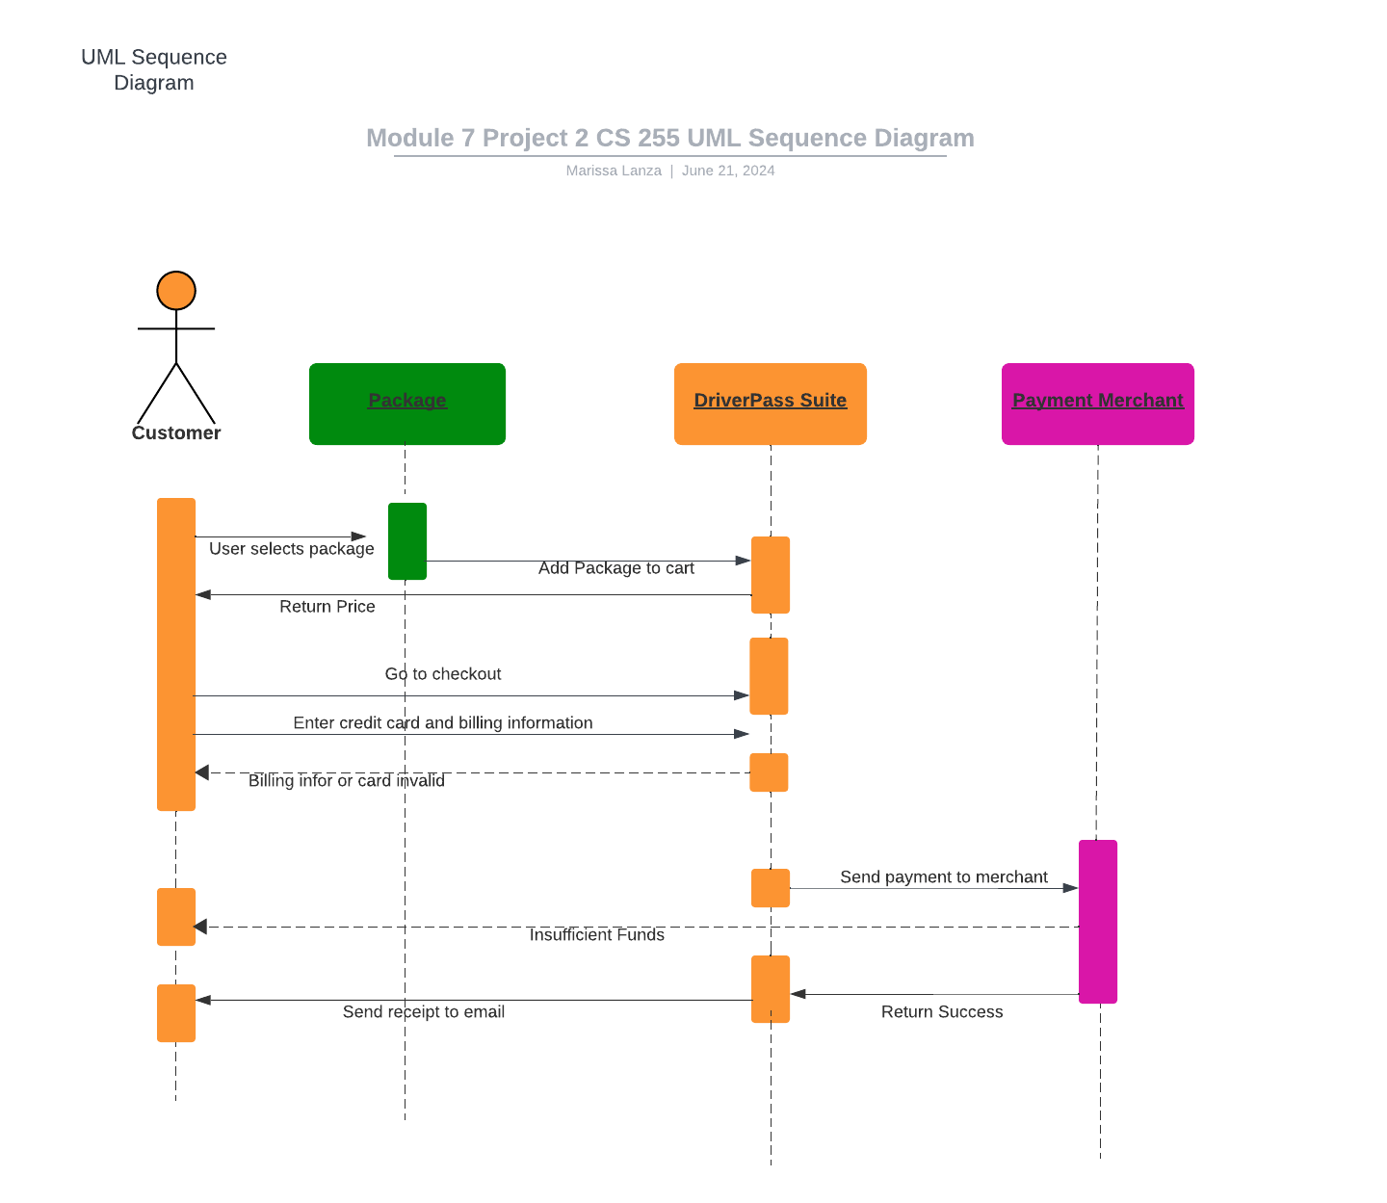

### UML Class Diagram

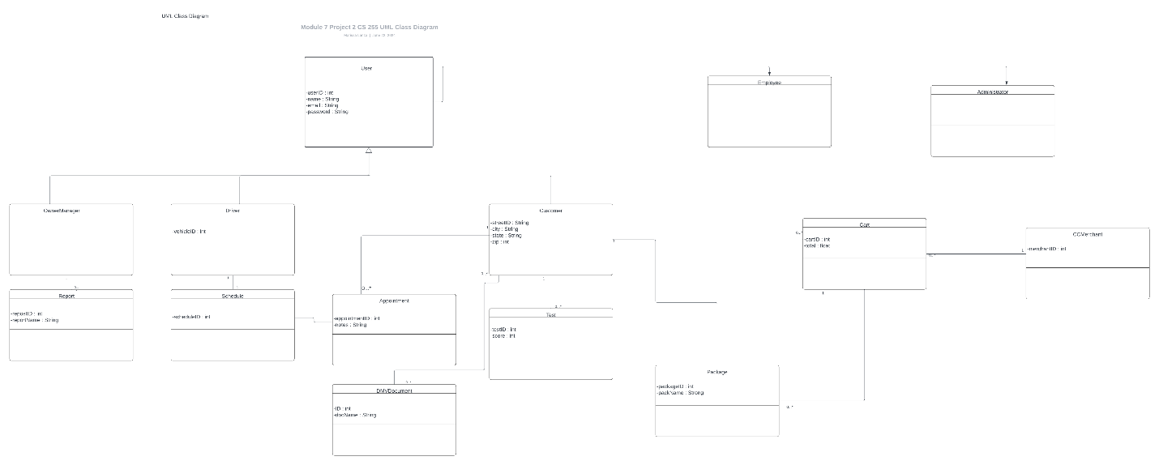

## Technical Requirements

*[Based on the diagrams you have created, describe the technical requirements of your system. These requirements should address the required hardware, software, tools, and infrastructure necessary for your system design.]*

## Technical Requirements

* Hardware
  + Dedicated Server
  + Internet connection
  + Storage for database and website data
  + Computer or mobile device for user to access website
  + A firewall to protect website ports
* Software
  + Windows Server (recommended), most stable release
  + SQL Server for database (recommended), most stable release
  + Backup software for website and database
  + A web server like Apache
  + Security software to prevent malware
* Geographic Information
  + Website should be accessible in America
  + Server for website and database is secured in data center
  + Server should be in a central location